**Praktik Jaringan Komputer Enterprise**

**MODUL 1**



**Disusun oleh :**

Cintia Dwi Christinawati

V3921005

**Dosen :**

Yusuf Fadila Rachman, S.Kom., M.Kom

**PS D-III TEKNIK INFORMATIKA**

**SEKOLAH VOKASI**

**UNIVERSITAS SEBELAS MARET**

**2022**

# 2.2.13 Packet Tracer – Point-to-Point Single-Area OSPFv2 Configuration

Topology.

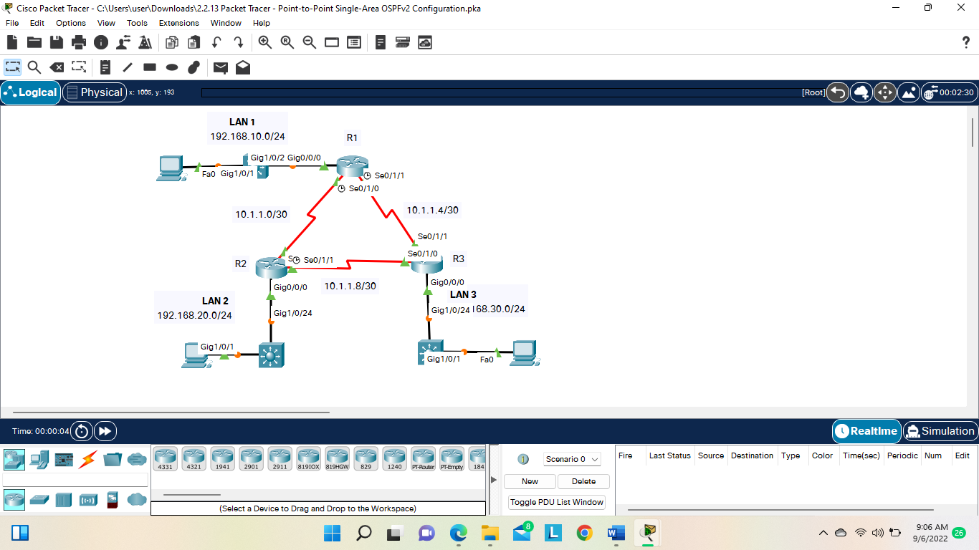

**Part 1 : Configure Router IDs**

• R1: 1.1.1.1

• R2: 2.2.2.2

• R3: 3.3.3.3

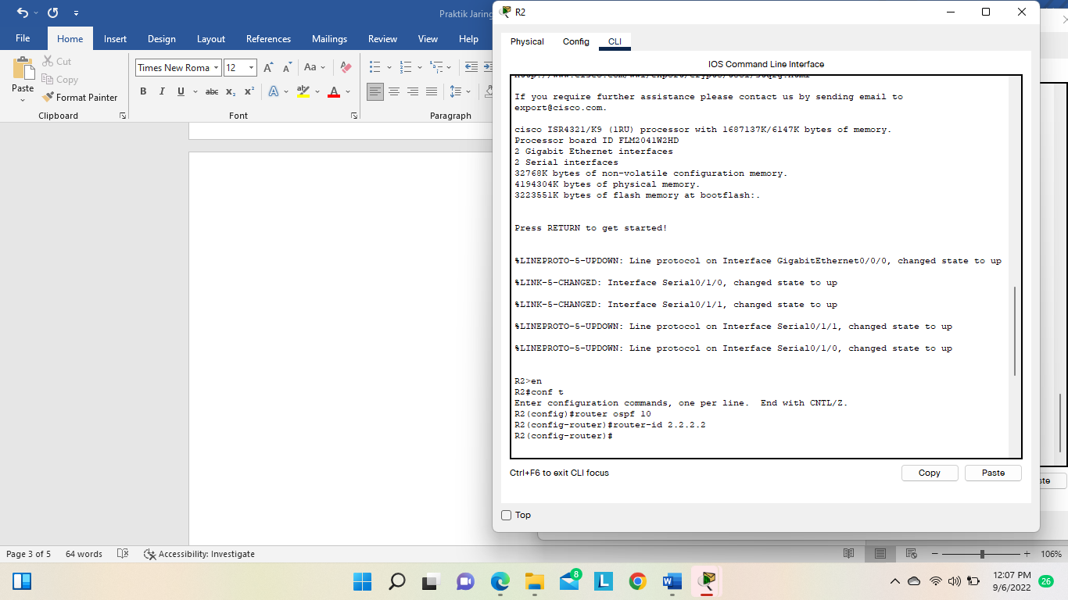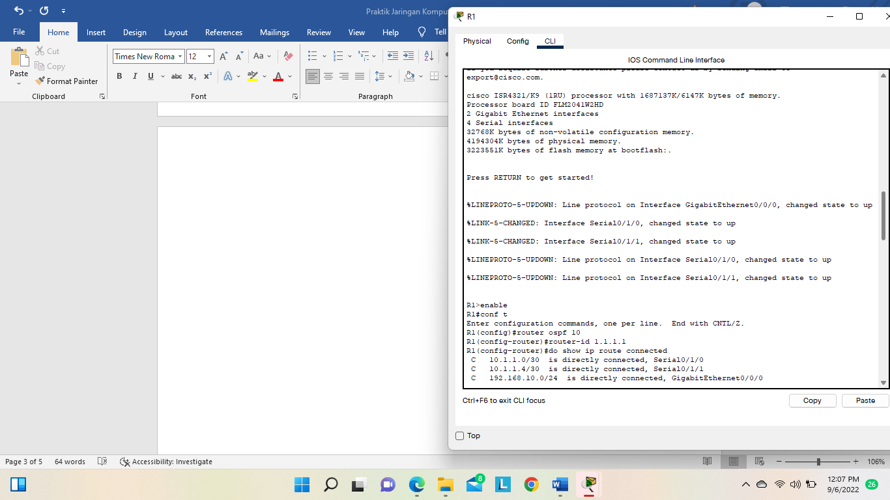

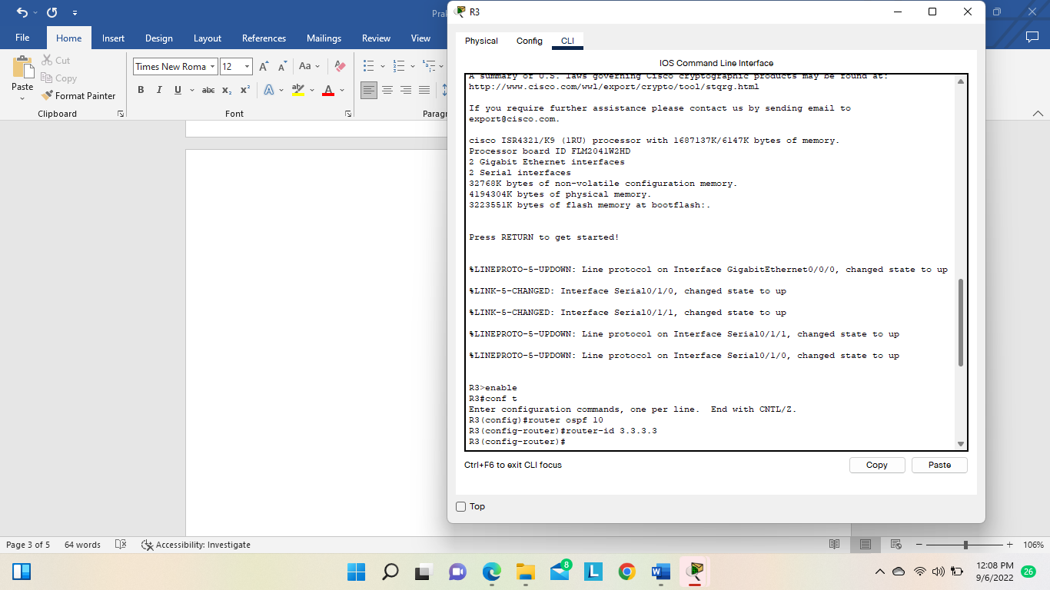

**Part 2: Configure Networks for OSPF Routing**

Step 1 Configure networks for OSPF routing using network commands and wildcard masks. Question

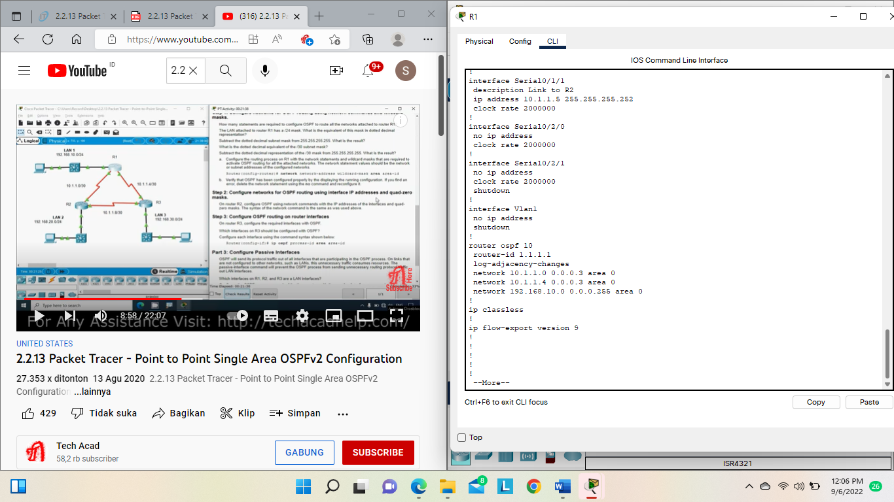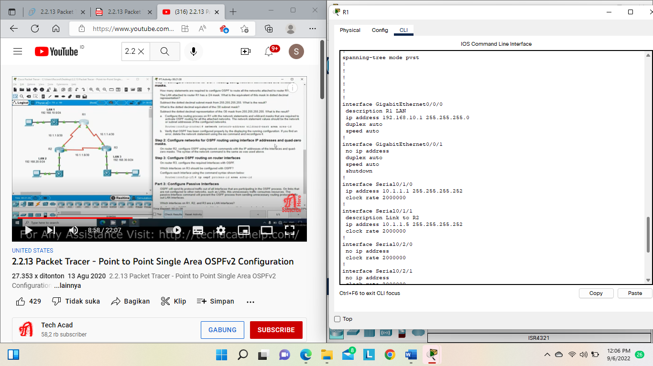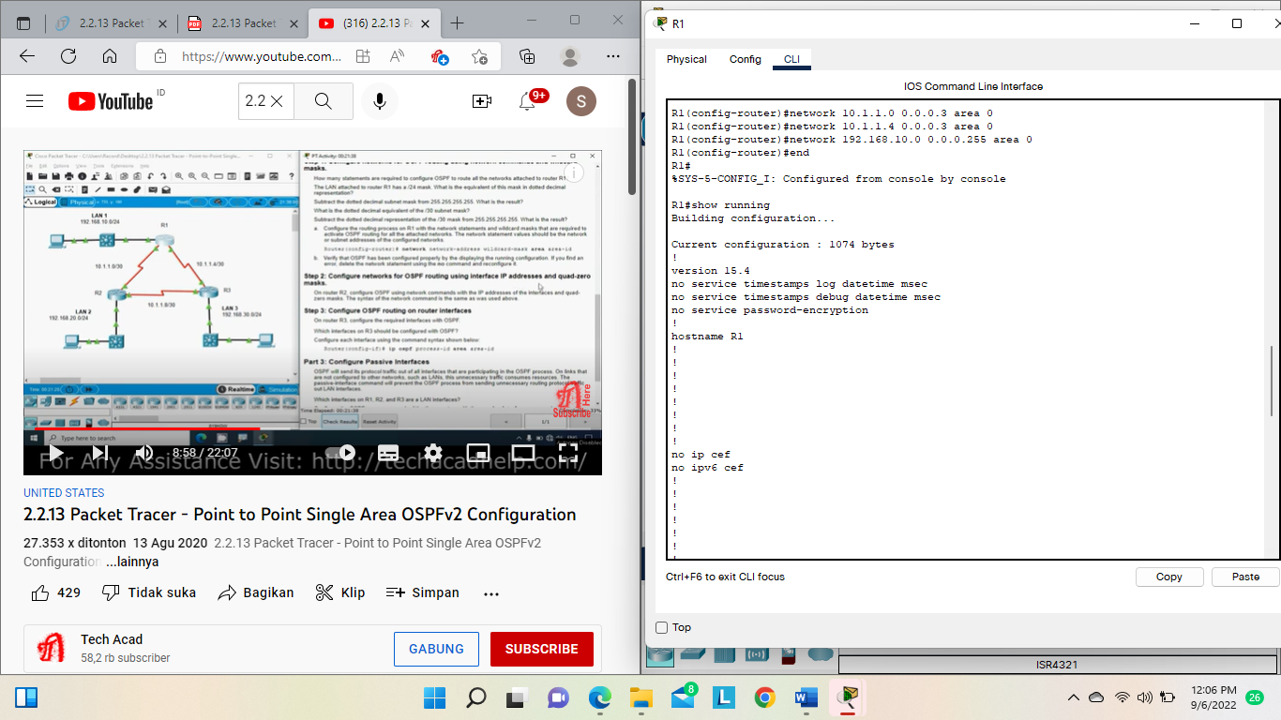

Step 2 Configure networks for OSPF routing using interface IP addresses and quad-zero masks.

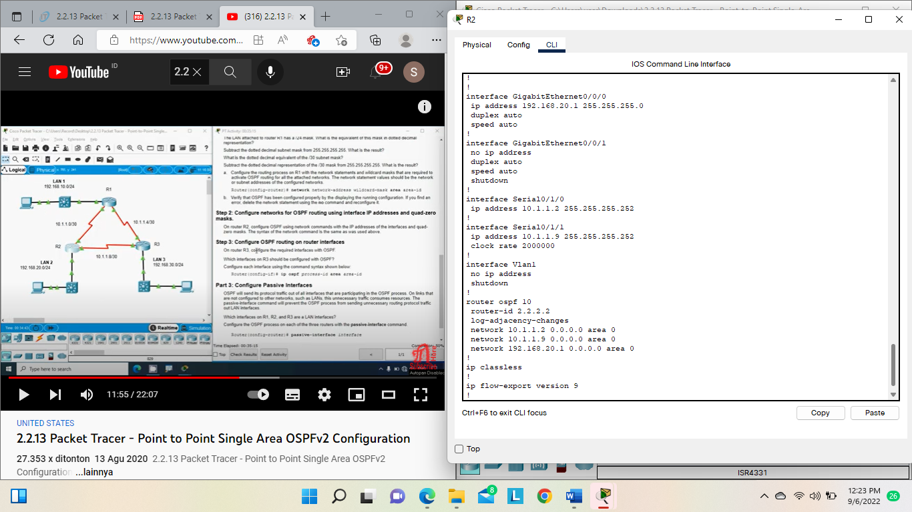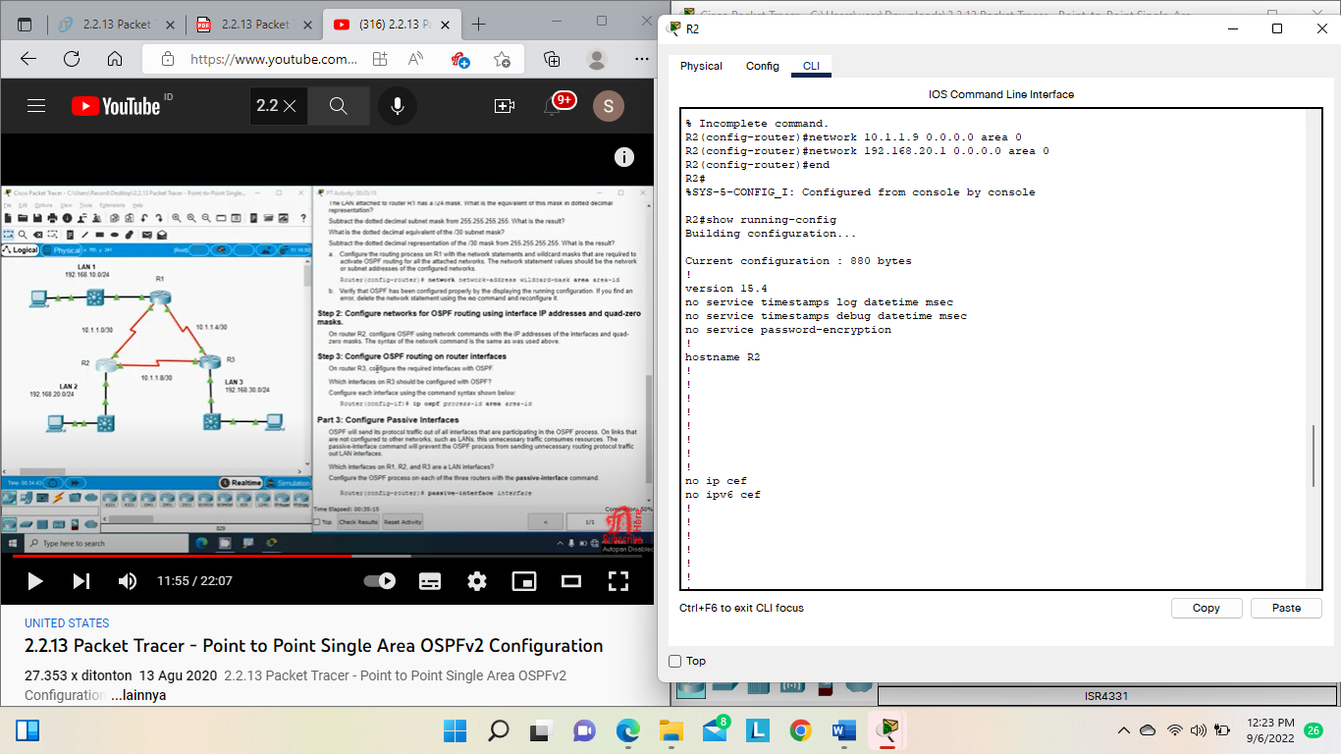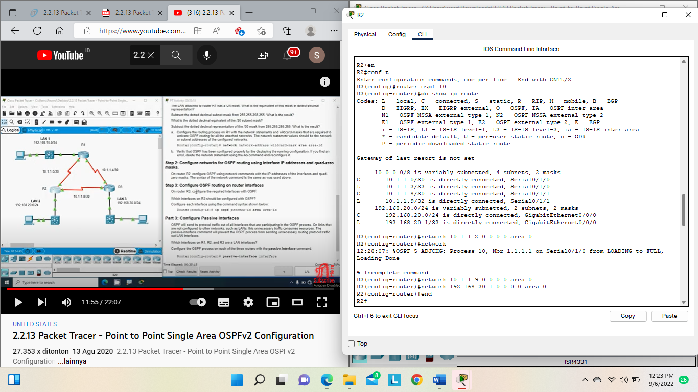

Step 3 Configure OSPF routing on router interfaces

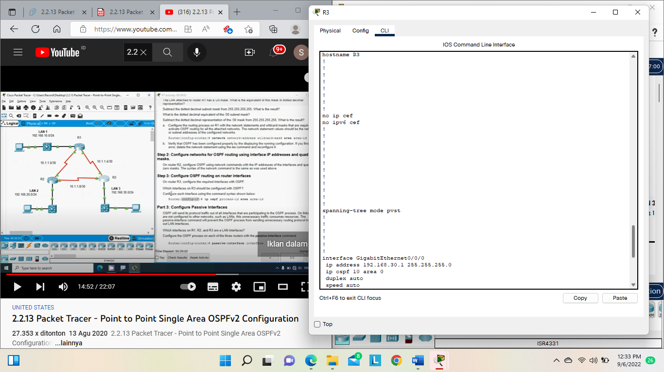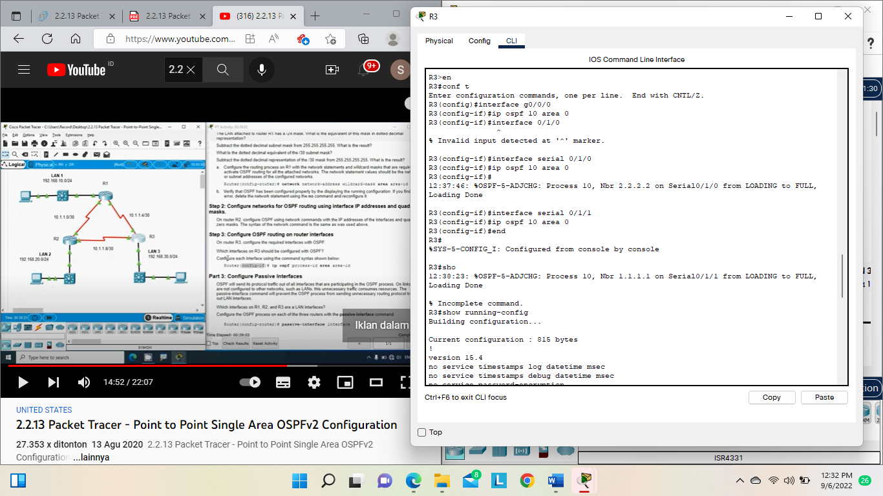

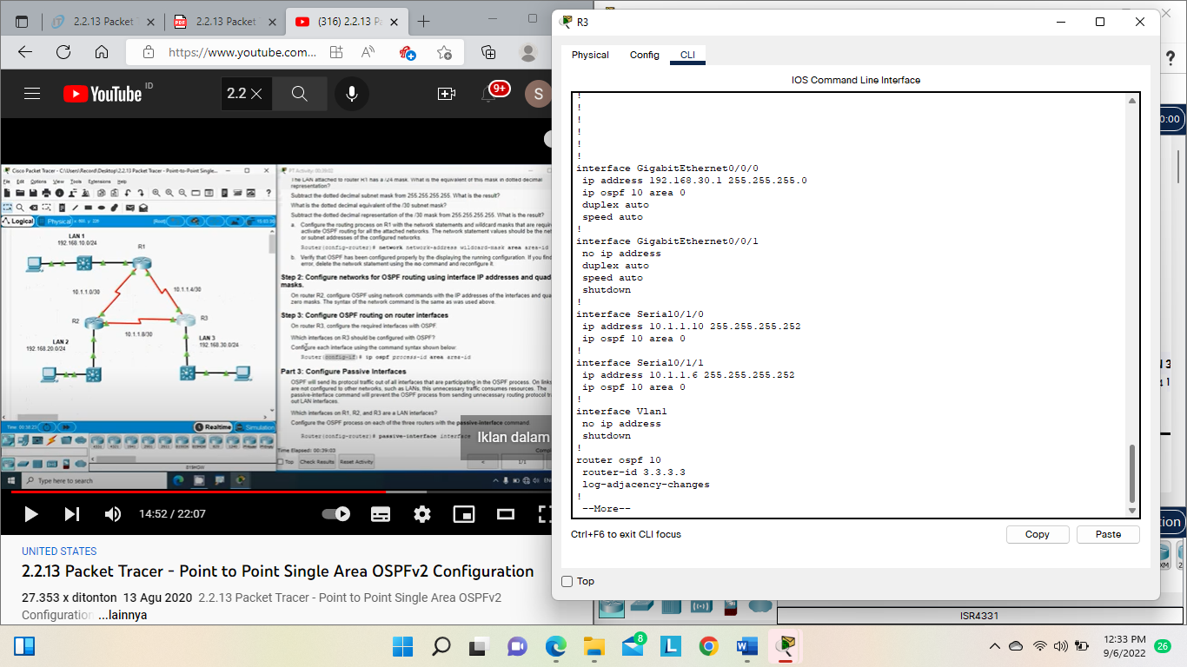

**Part 3: Configure Passive Interfaces**

**G0/0/0 on all three routers.**

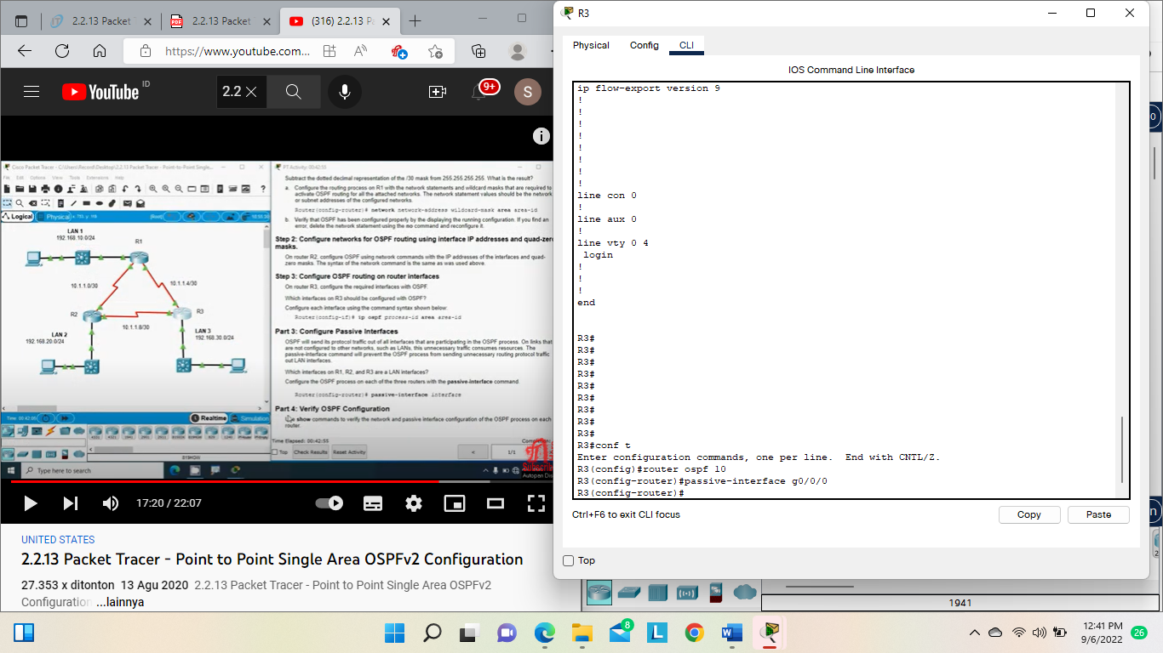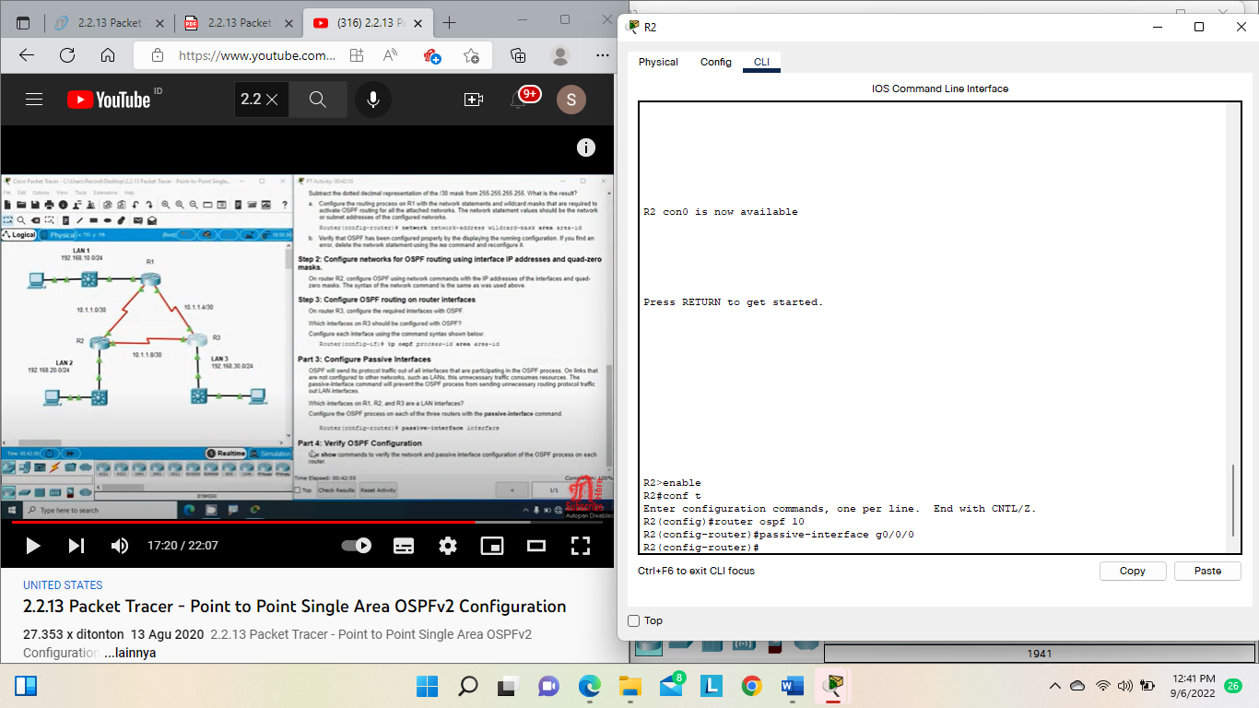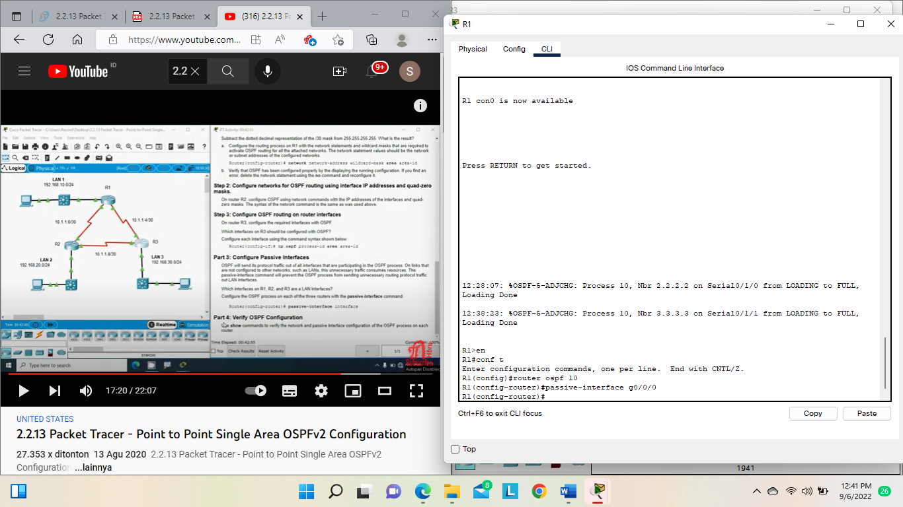

**Part 4: Verify OSPF Configuration**

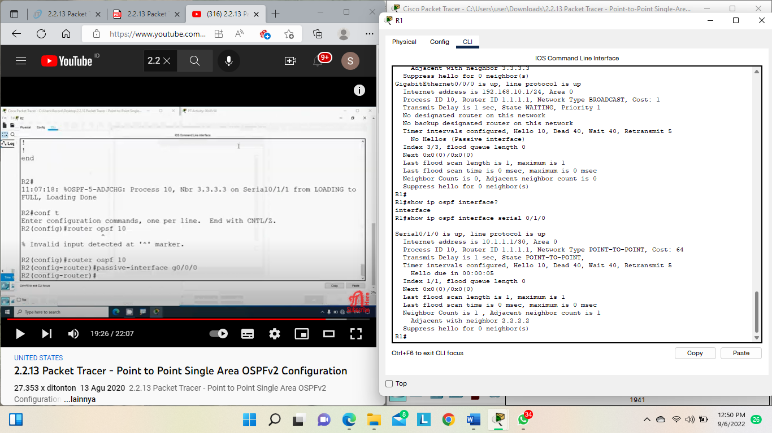**Router 1**

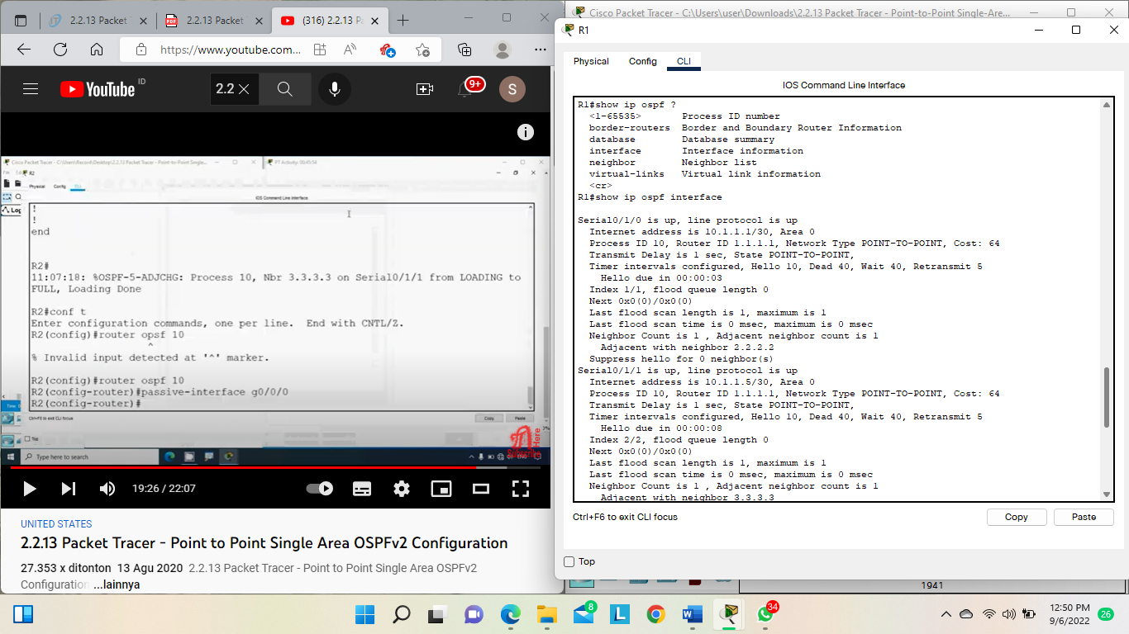

**Router 2**

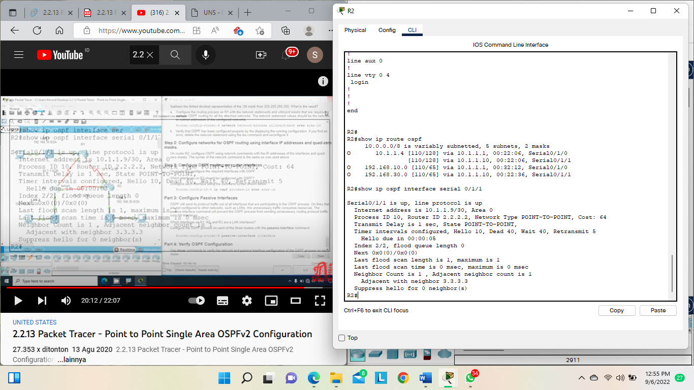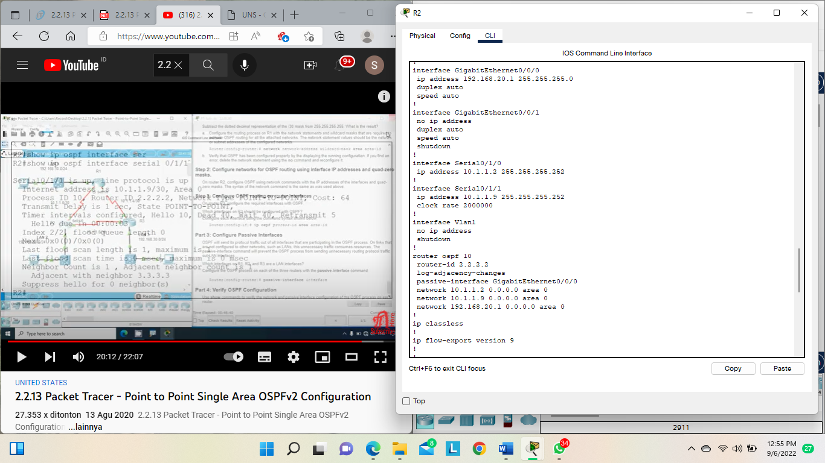

**Router 3**

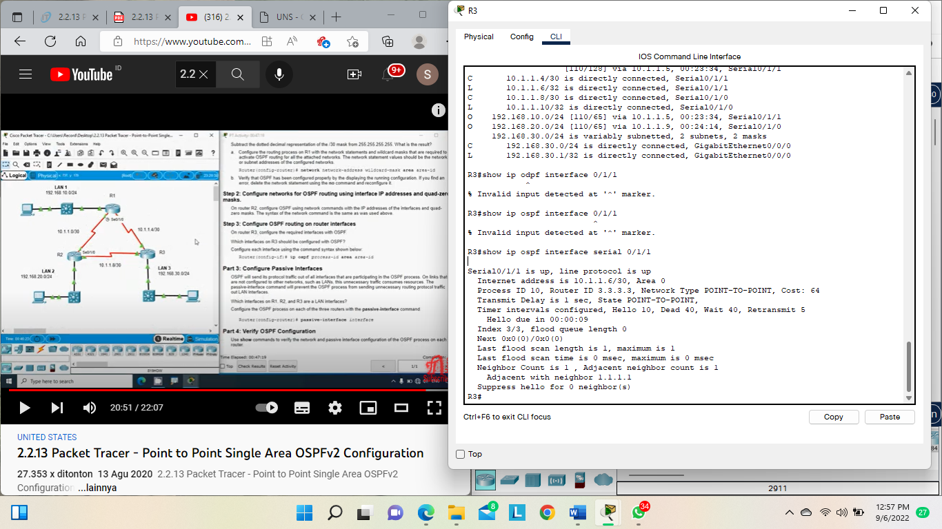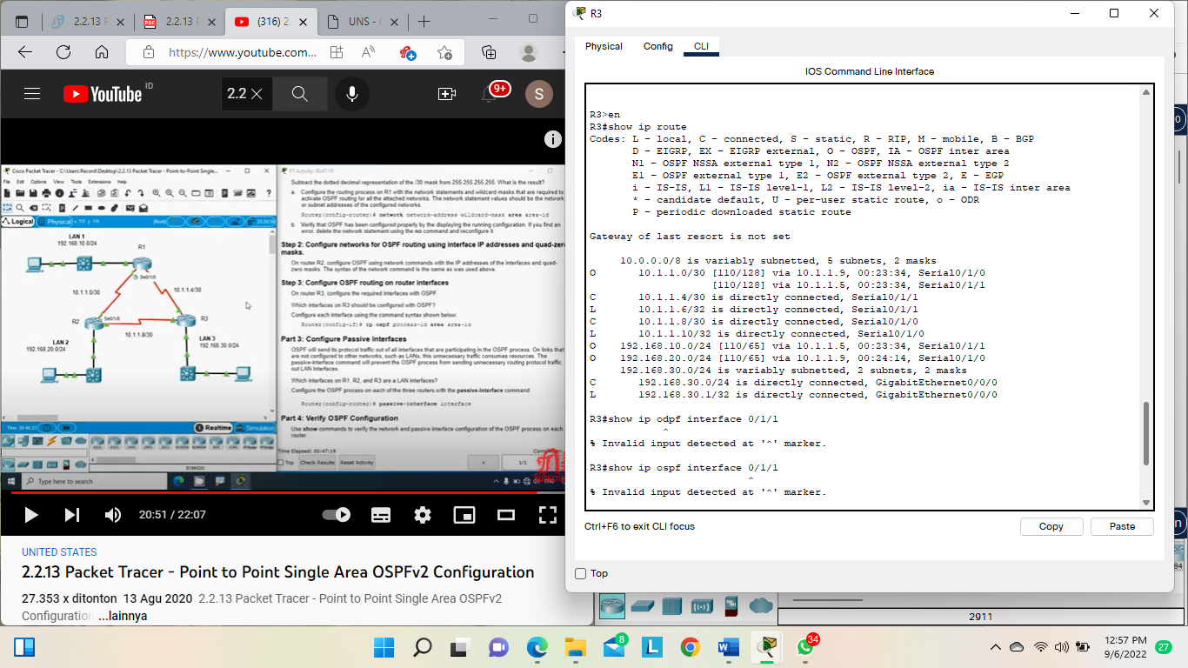

**Hasil dijalankan :**

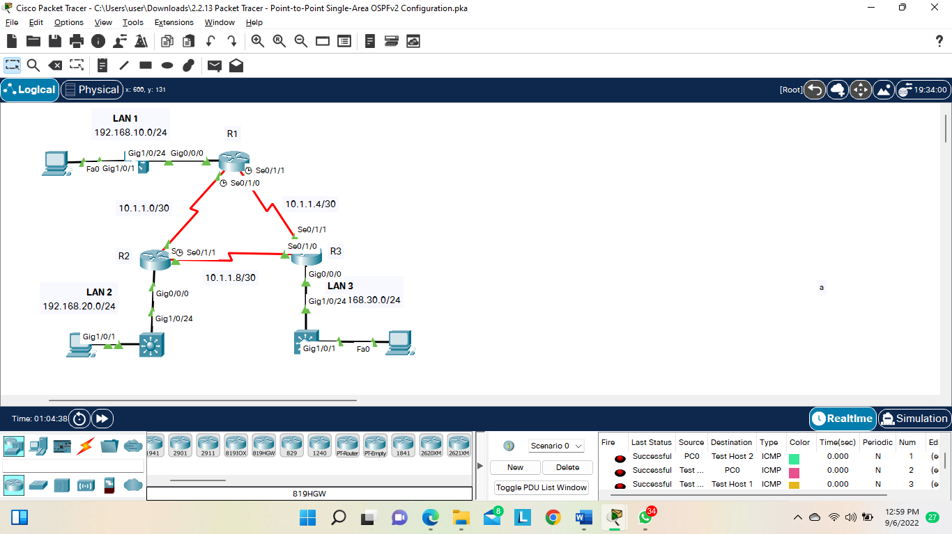

# 2.3.11 Packet Tracer – Determine the DR and BDR

Topology

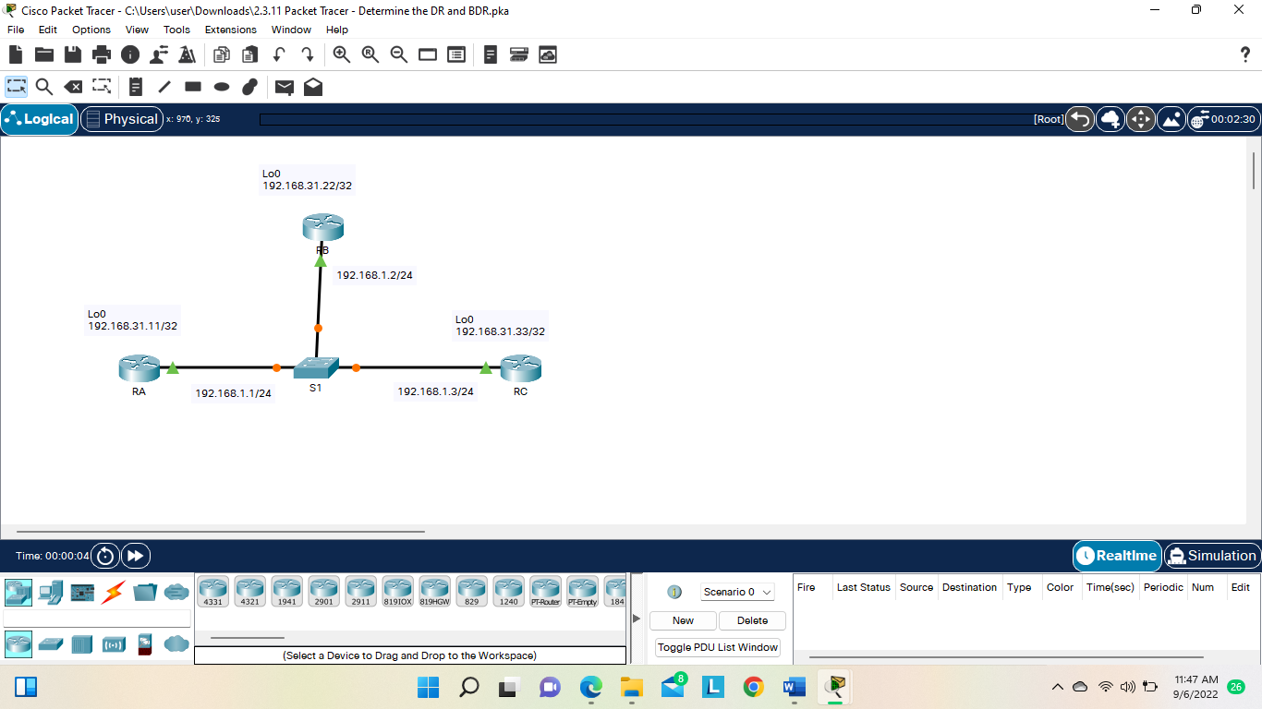

**Part 1: Examine DR and BDR Changing Roles**

Step 1: Wait until the amber link lights turn green

Step 2: Verify the current OSPF neighbor states.

RA# show ip ospf neighbor

RB# show ip ospf neighbor

RC# show ip ospf neighbor

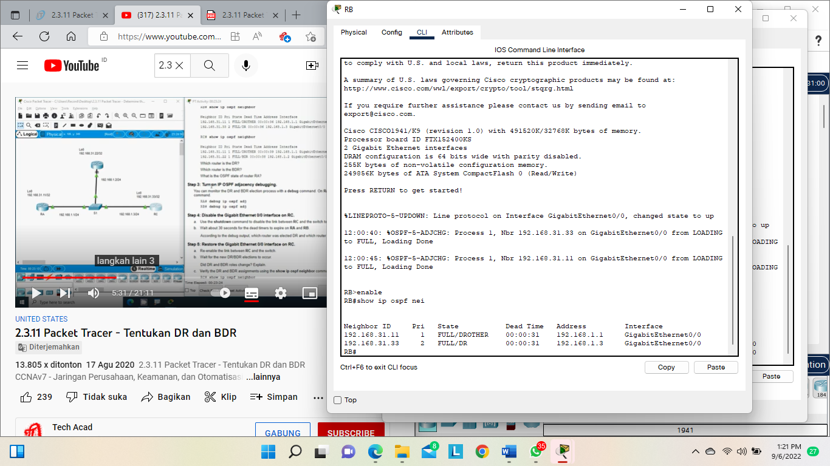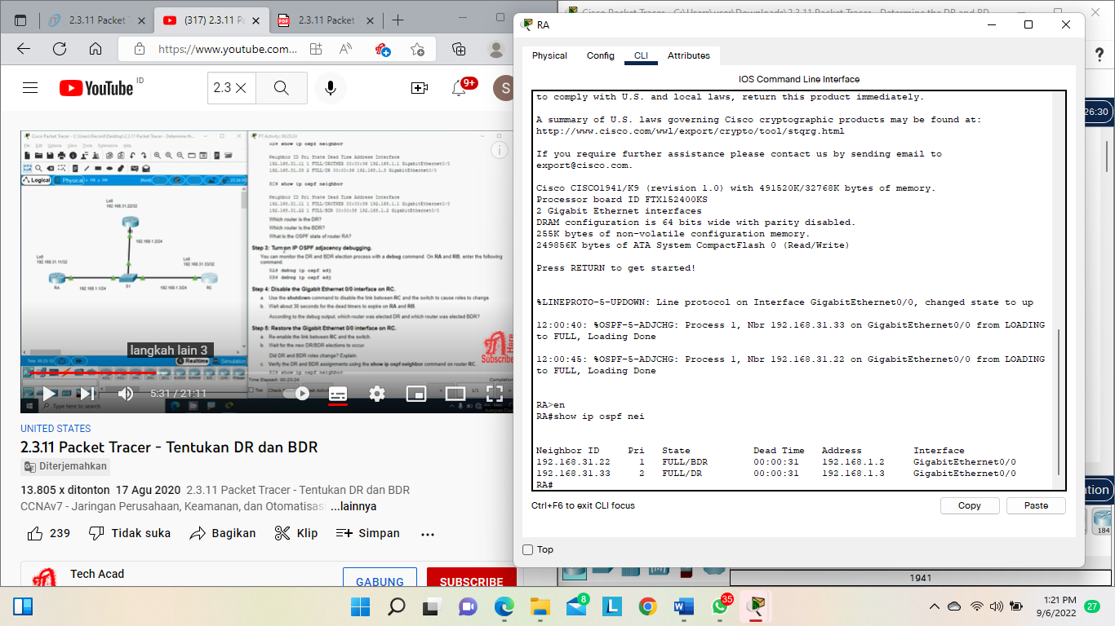

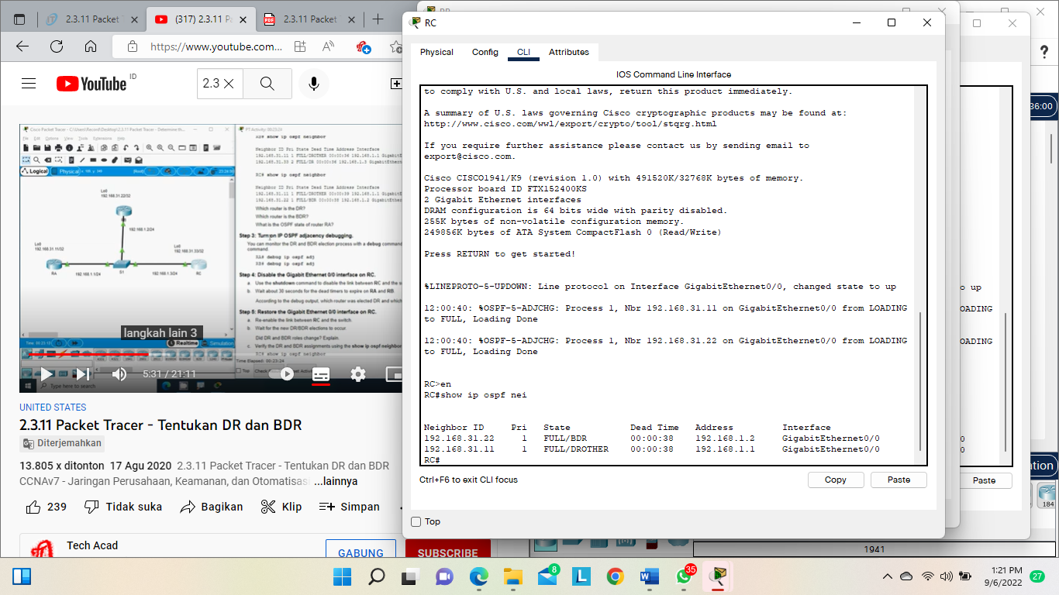

Step 3: Turn on IP OSPF adjacency debugging.

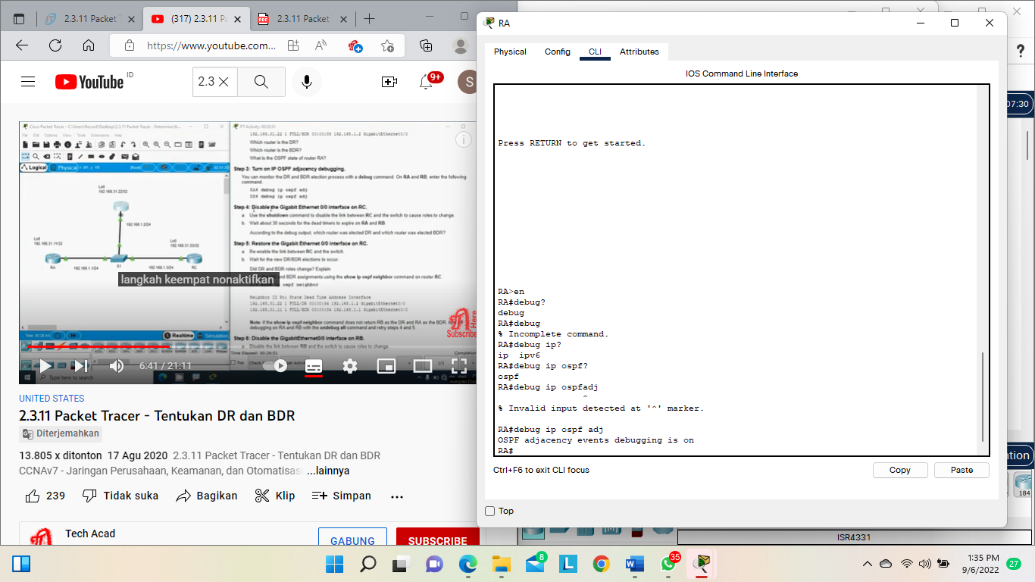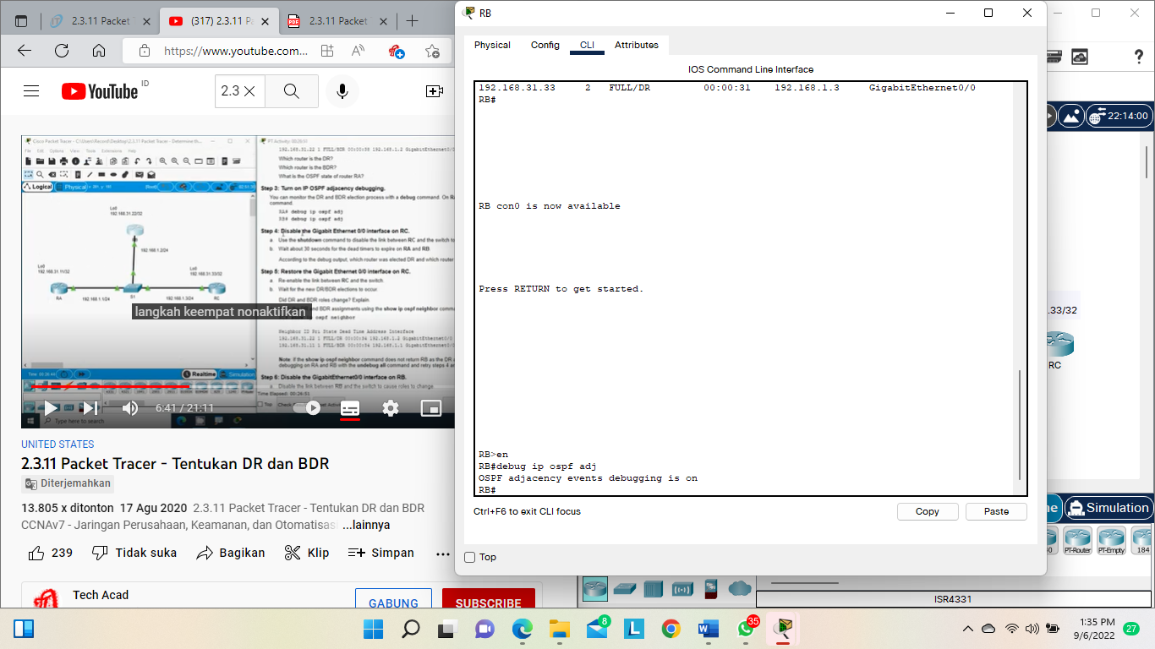

Step 4: Disable the Gigabit Ethernet 0/0 interface on RC.

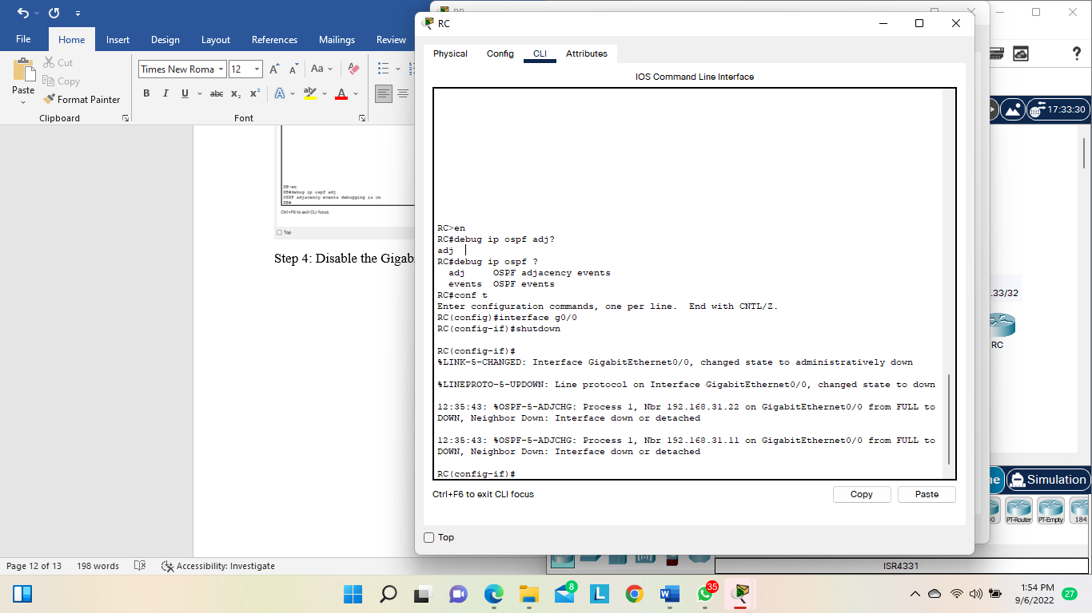

Step 5: Restore the Gigabit Ethernet 0/0 interface on RC.

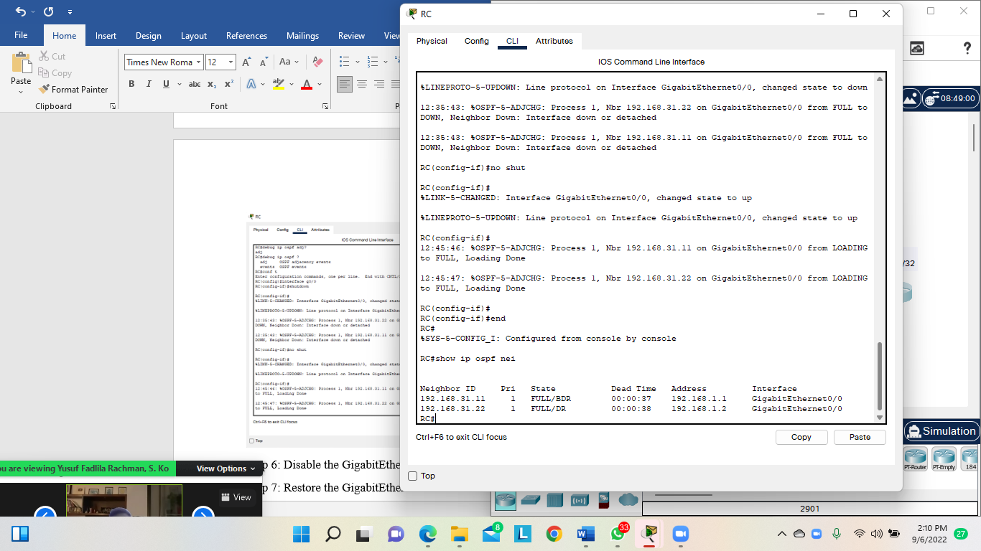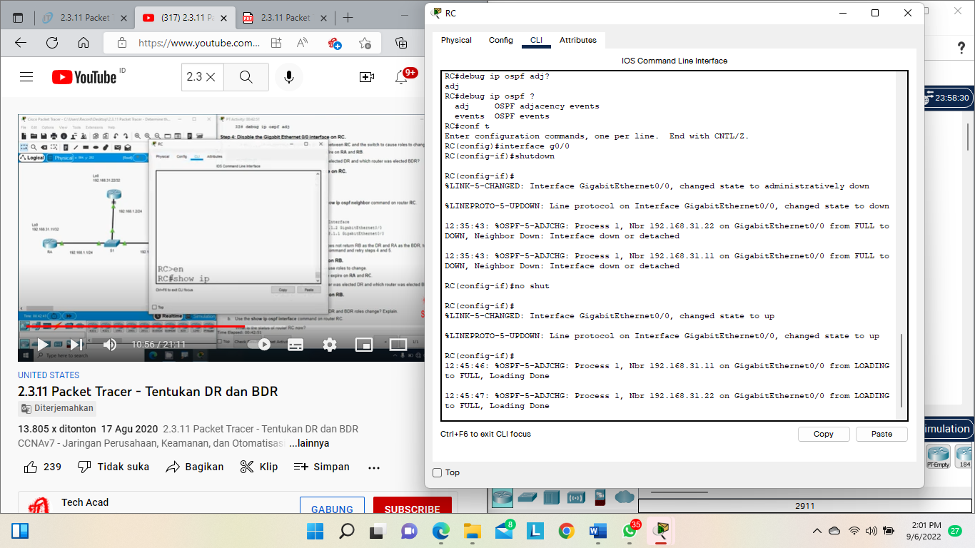

Step 6: Disable the GigabitEthernet0/0 interface on RB.

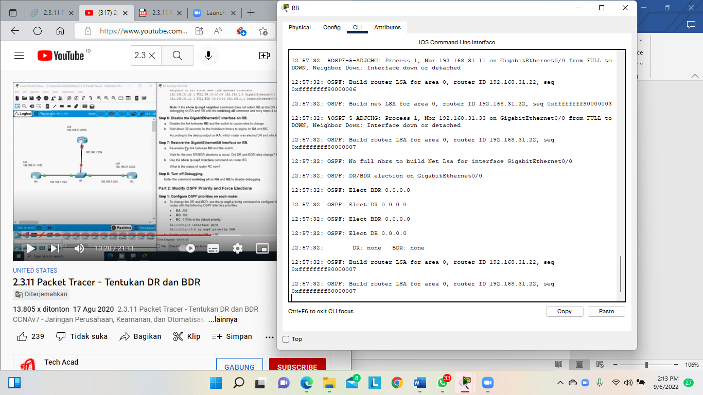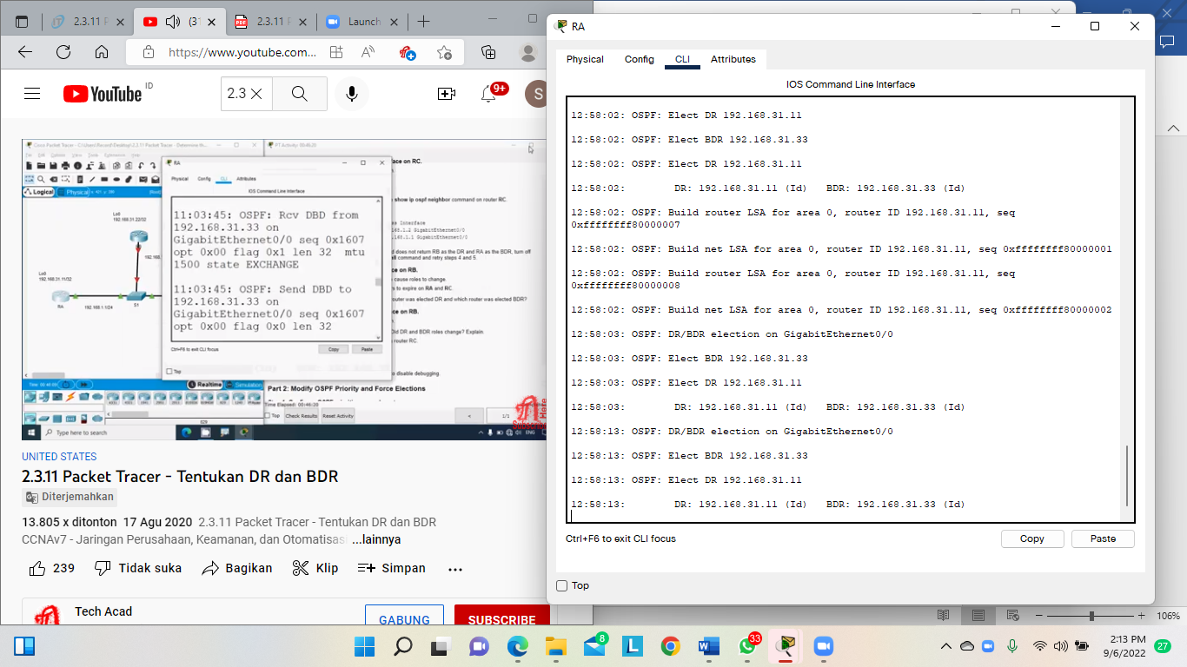

Step 7: Restore the GigabitEthernet0/0 interface on RB

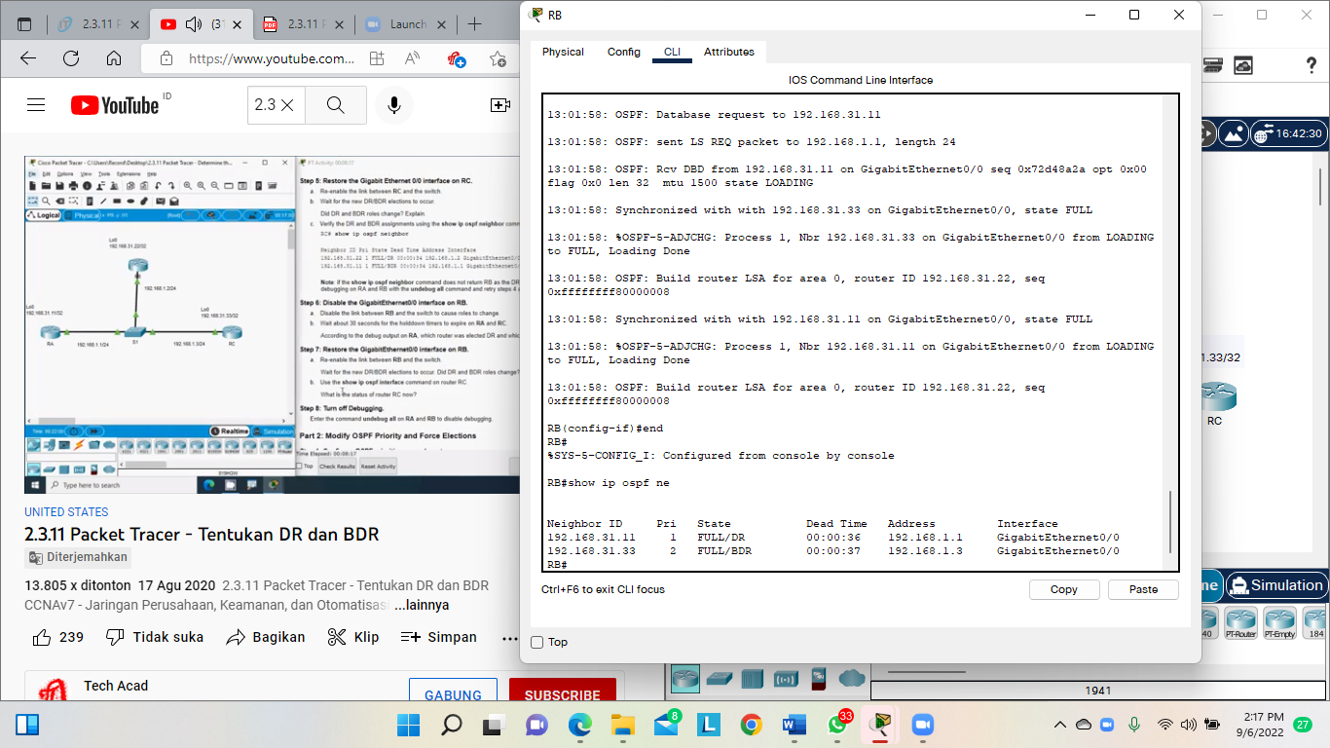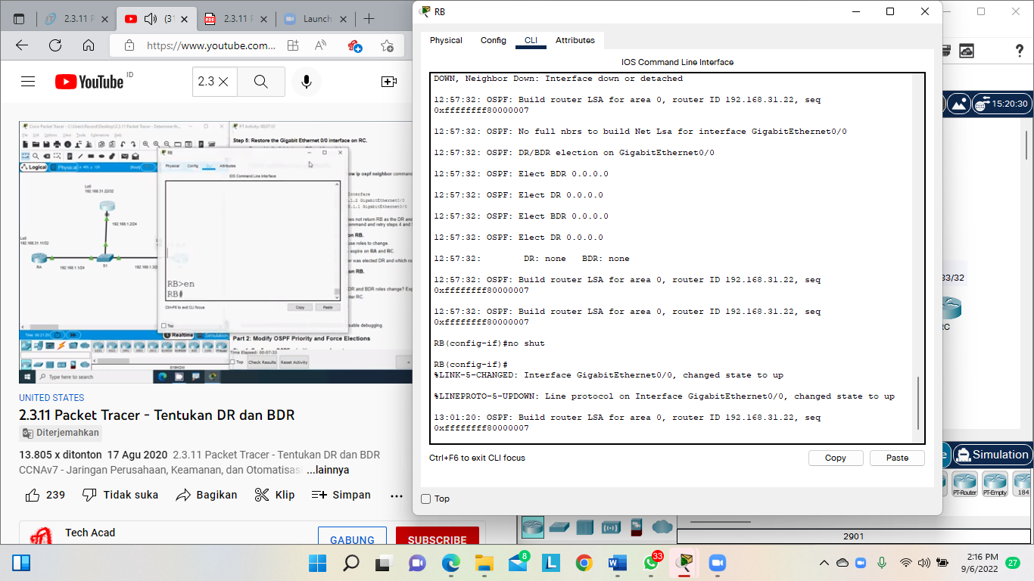

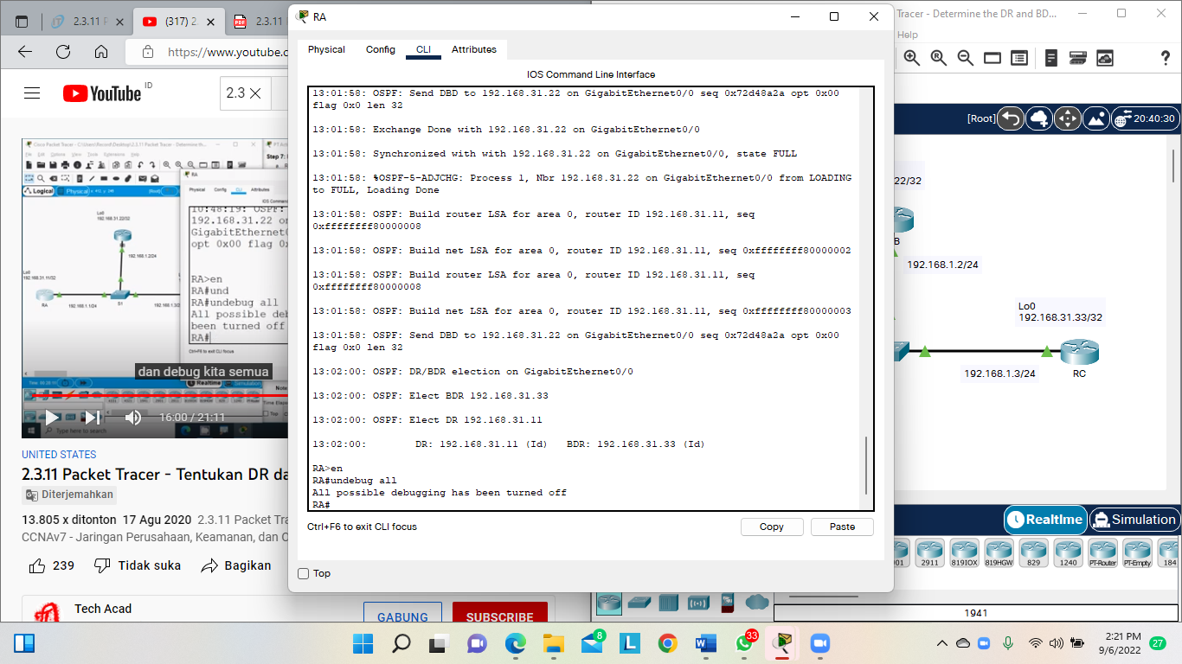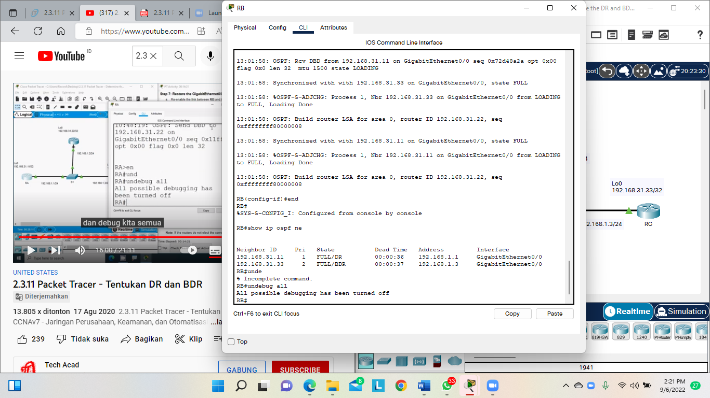Step 8: Turn off Debugging.

**Part 2: Modify OSPF Priority and Force Elections**

Step 1: Configure OSPF priorities on each router.

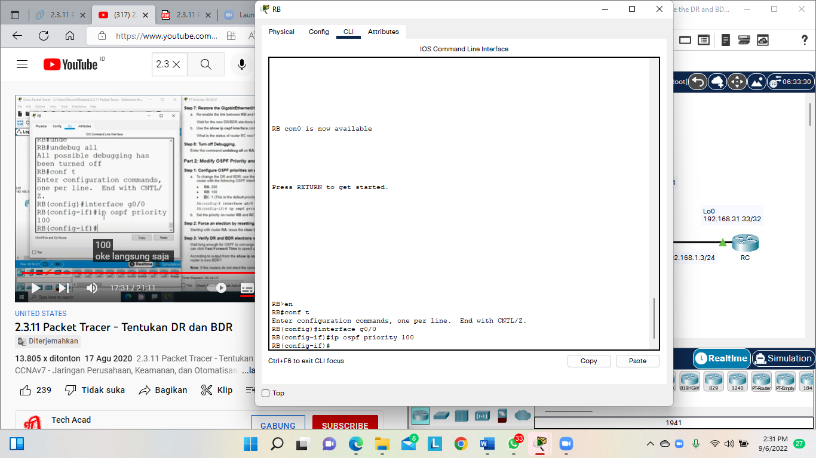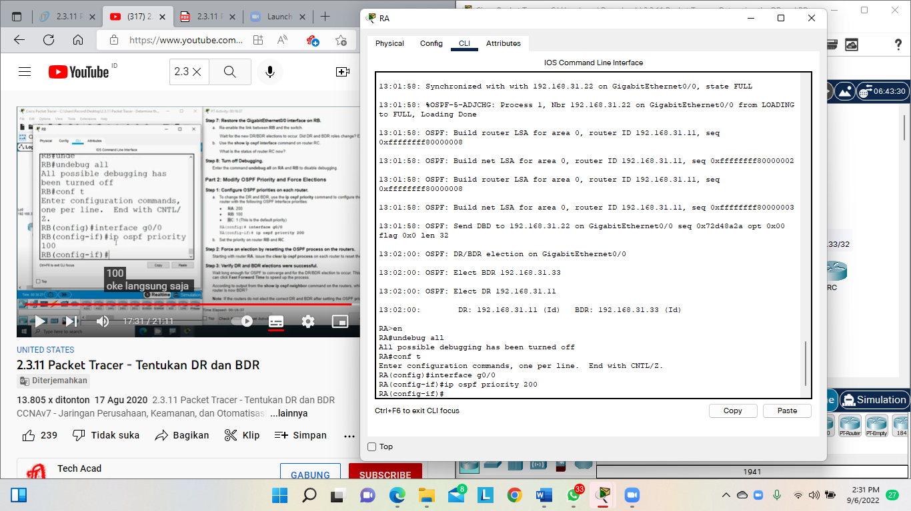

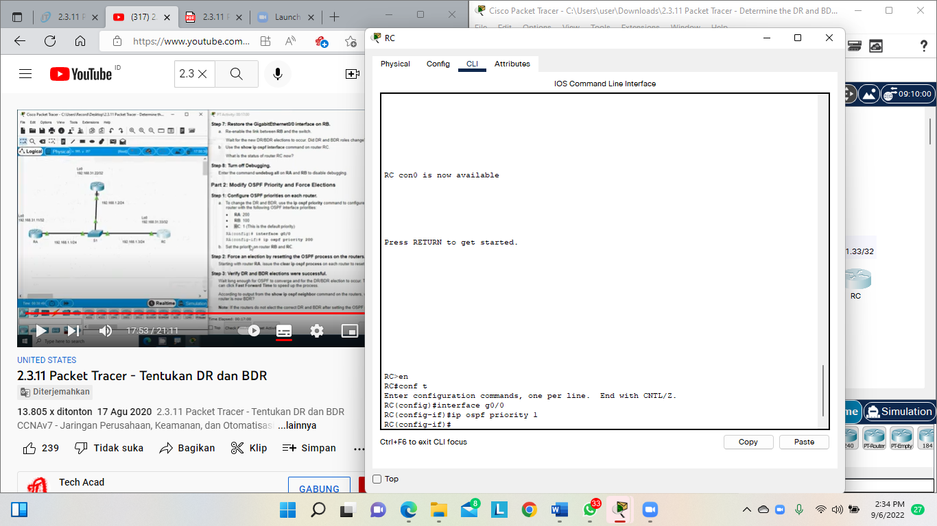

Step 2: Force an election by resetting the OSPF process on the routers.

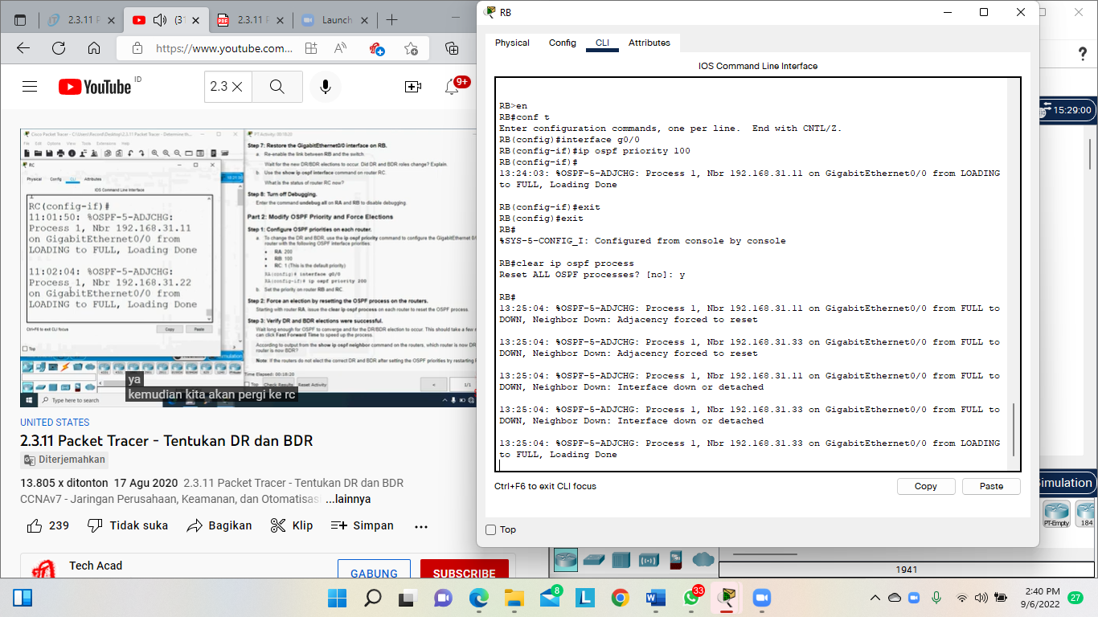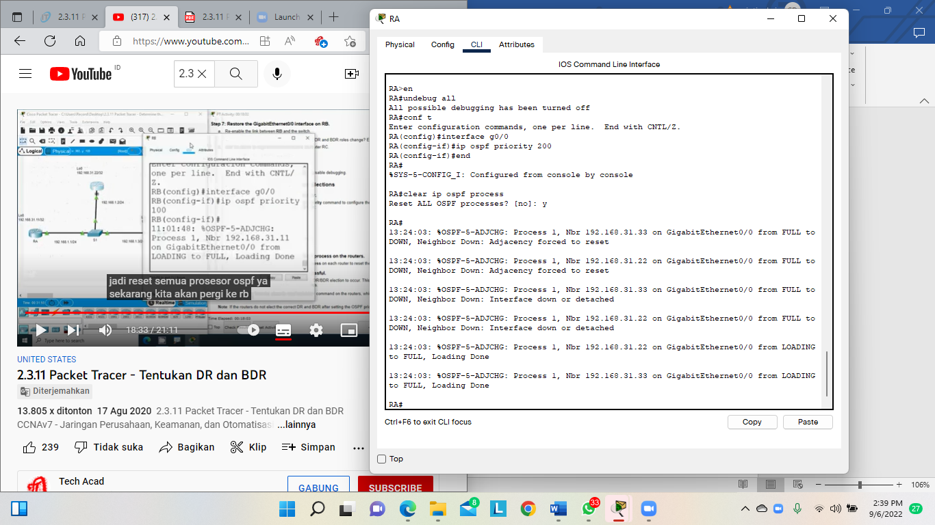

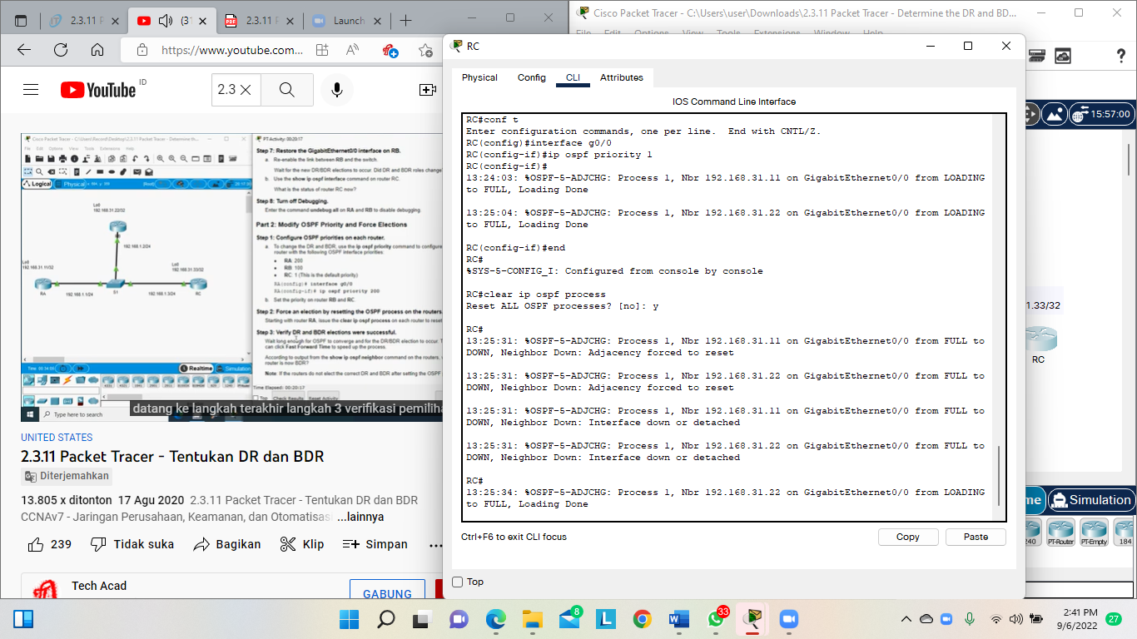

Step 3: Verify DR and BDR elections were successful.

Hasil Run :

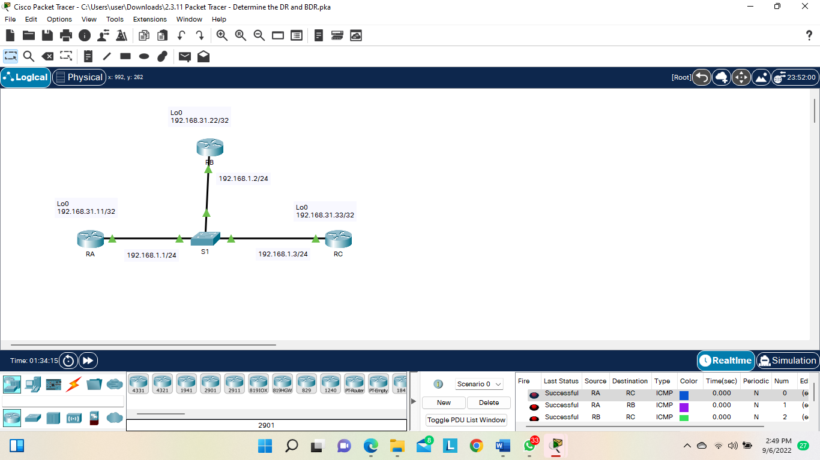

# 2.4.11 Packet Tracer – Modify Single-Area OSPFv2

Topology

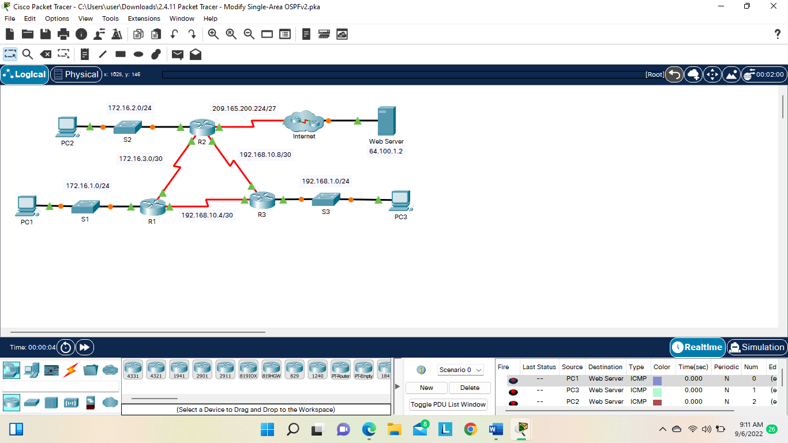

**Part 1: Modify OSPF Default Settings Step**

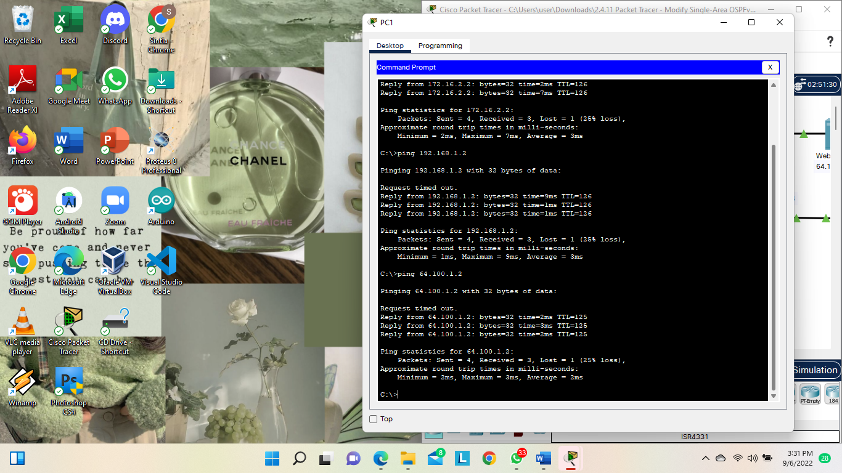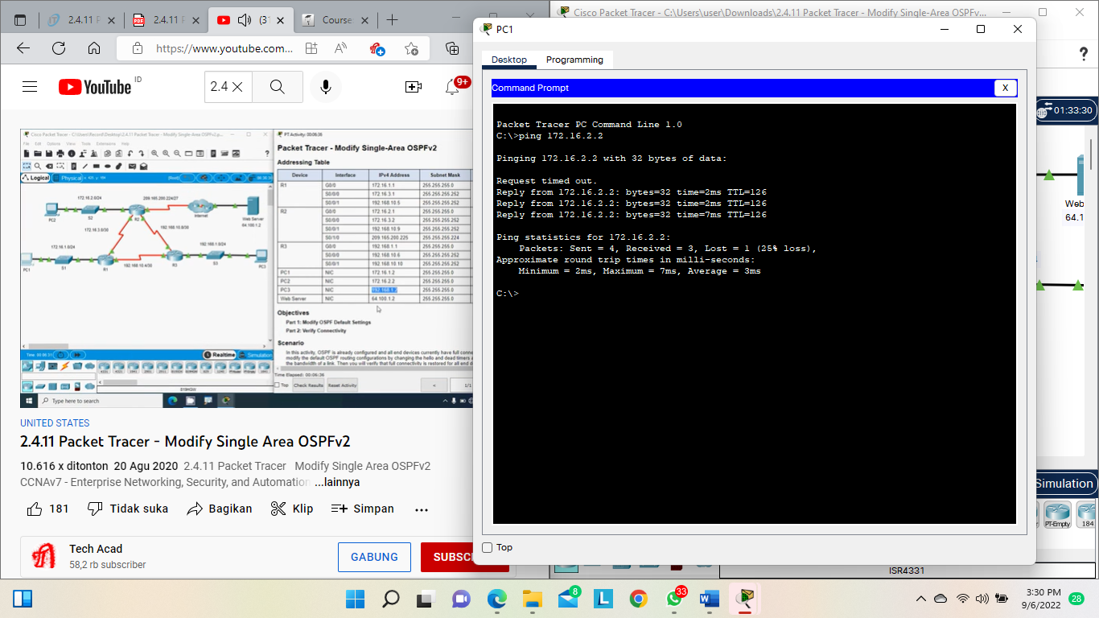Step 1: Test connectivity between all end devices.

Step 2: Adjust the hello and dead timers between R1 and R2.

1. Enter the following commands on R1

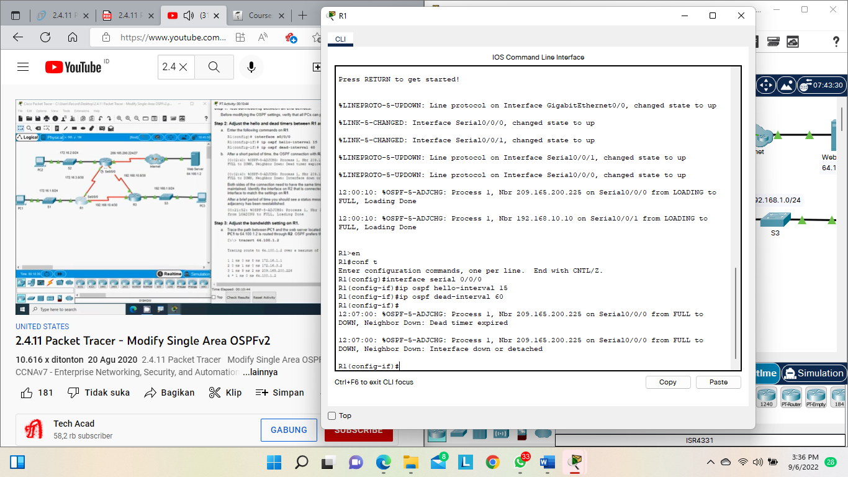

1. After a short period of time, the OSPF connection with R2 will fail, as shown in the router output

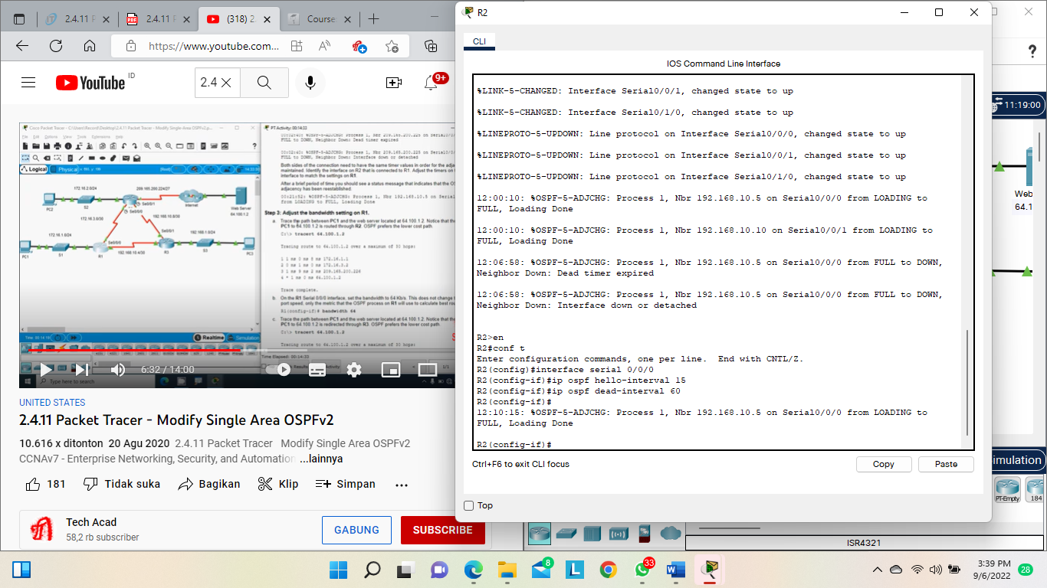

Step 3: Adjust the bandwidth setting on R1.

1. Trace the path between PC1 and the web server located at 64.100.1.2. Notice that the path from PC1 to 64.100.1.2 is routed through R2. OSPF prefers the lower cost path.

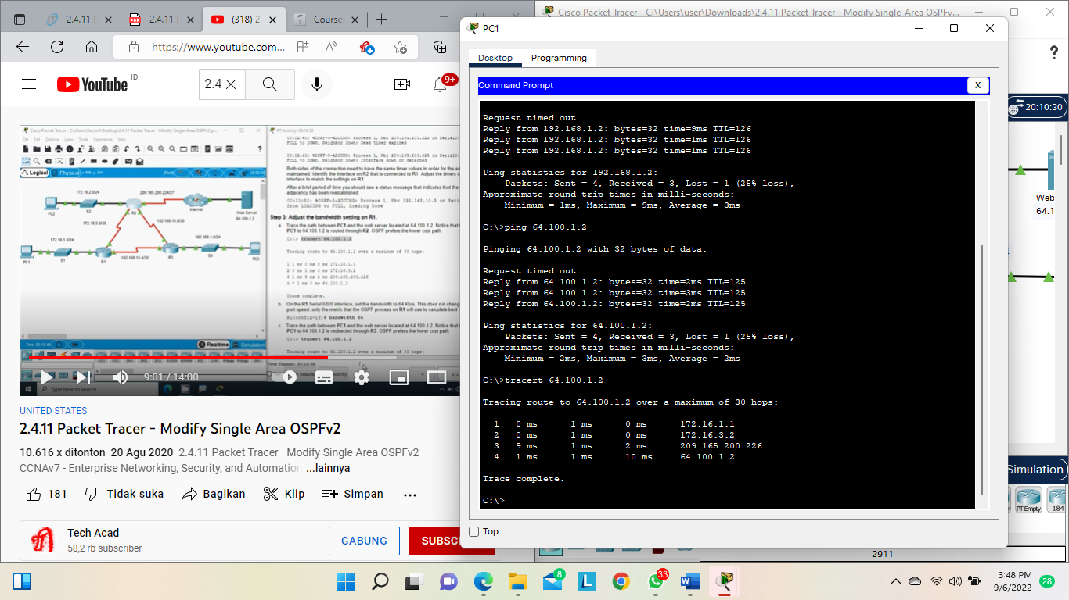

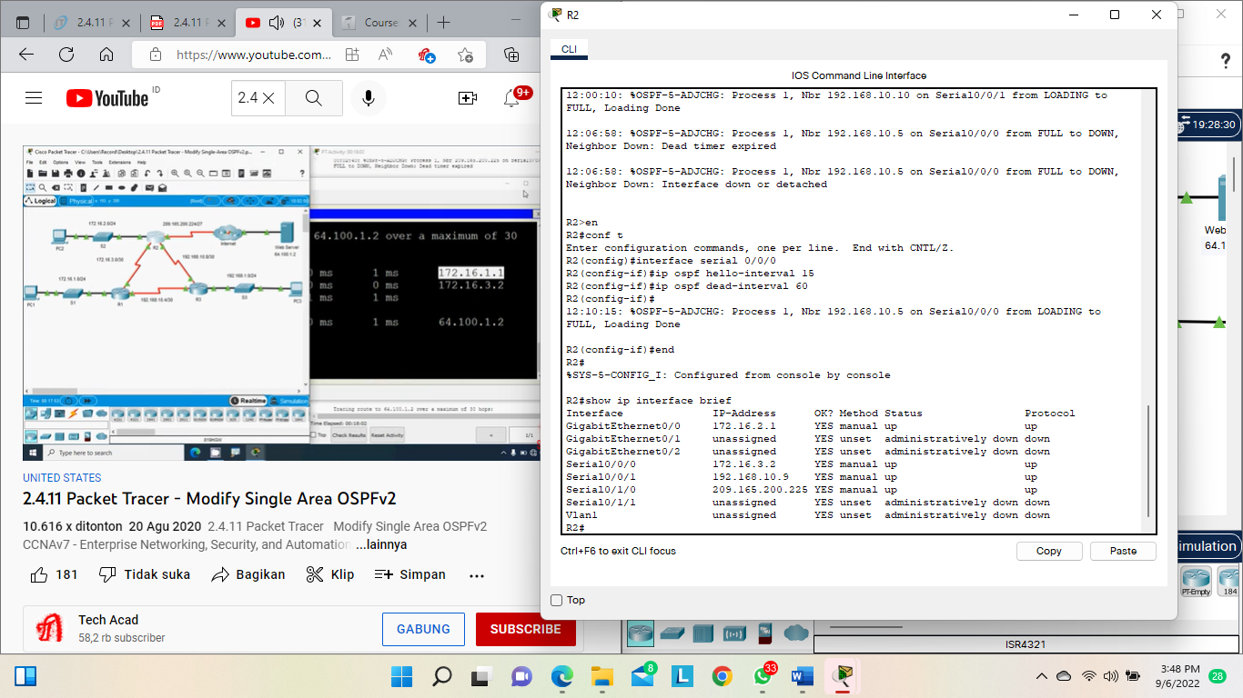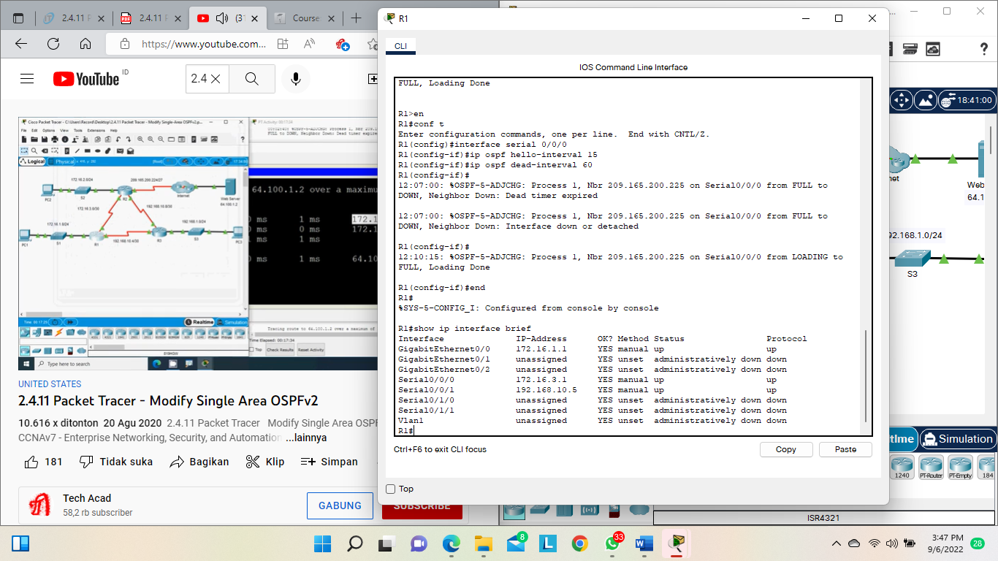

1. On the R1 Serial 0/0/0 interface, set the bandwidth to 64 Kb/s. This does not change the actual port speed, only the metric that the OSPF process on R1 will use to calculate best routes.

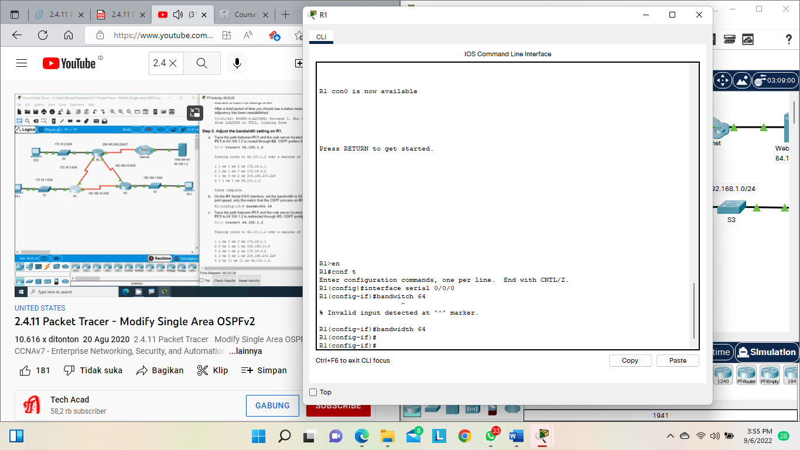

1. Trace the path between PC1 and the web server located at 64.100.1.2. Notice that the path from PC1 to 64.100.1.2 is redirected through R3. OSPF prefers the lower cost path.

**Hasil apabila dijalankan :**

